5th March 2019

**YOKOHAMA to Launch European Sales of Ultra Lightweight and Fuel-Efficient “BluEarth-air EF21”**

YOKOHAMA announced today that it will begin selling its “BluEarth-air EF21” in Europe on a limited-basis from this spring. The “BluEarth-air EF21” uses the most advanced technologies to achieve a new lightweight design that enhances its environmentally sound features. The tyre will be available in only one size, 205/55R16 91V.   
  
Seeking to create a more environmentally friendly tyre, YOKOHAMA has employed its latest design technique to achieve a lighter tyre that conserves resources by using less material and improves fuel efficiency by contributing to lighter overall vehicle weight. In addition to being light, the “BluEarth-air EF21” has achieved a thin yet highly rigid structure and a weight reduction of about 25% in the tyre’s mass. * The tyre also achieves excellent wet and fuel-efficient performance from the use of a newly developed special compound and YOKOHAMA’s state-of-the-art rubber mixing technology, Advanced Reaction Technology in Mixing. As a result, the “BluEarth-air EF21” has received the European tyre-grading system’s highest “A” grades for both rolling resistance and wet grip performance.   
  
BluEarth is a YOKOHAMA global tyre brand based on the concept of being “environmental, human, and socially friendly”. The brand’s diverse line-up also includes the high-performance, fuel-efficient “BluEarth-A”; the fuel-efficient “BluEarth RV-02” for minivans and crossover SUVs; and the “BluEarth-Es ES32”, a fuel-efficient standard tyre.   
  
* Compared with the “ADVAN dB V551”, the YOKOHAMA tyre considered to be the standard for tyre mass.

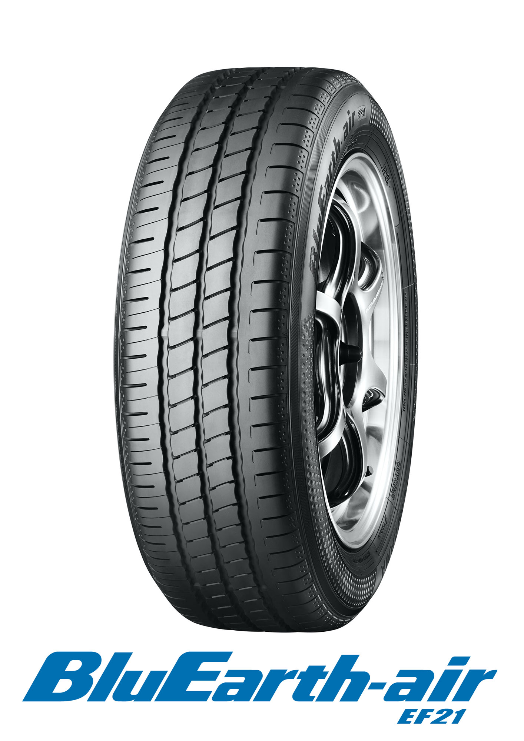

*BluEarth-air EF21*

##### Lightweight Design Technology

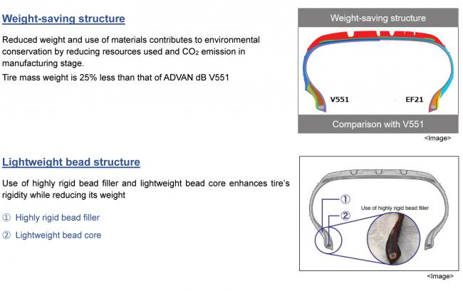

##### Keys to Fuel Efficiency and High Wet Performance

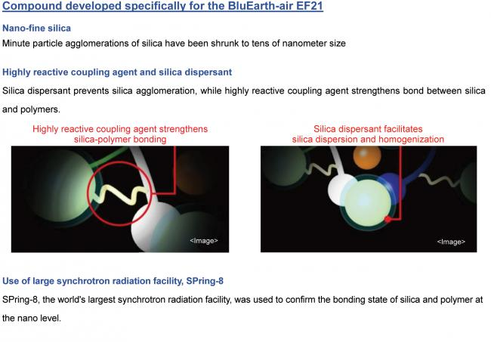

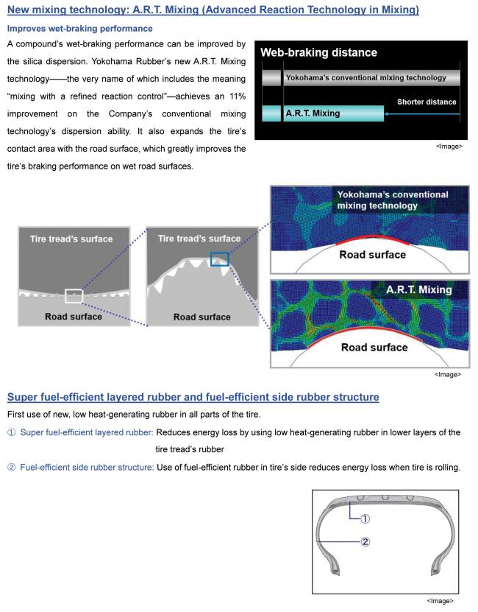

##### Application of YOKOHAMA’s State-of-the-art Technologies

